**Creating a Simple Application in SAP UI5**

**At the end of this tutorial you will come know:**

* Downloading Eclipse (sapui5 development tool)
* Installing SAPUI5 plug in Eclipse
* How to create a simple Application in ui5
* Introduction to very basic UI elements (input field, label and button)
* Working with Controller

**Downloading Eclipse:**

Download Eclipse using the following url:

http://www.eclipse.org/downloads/download.php?file=/technology/epp/downloads/release/kepler/SR2/eclipse-jee-kepler-SR2-win32-x86_64.zip

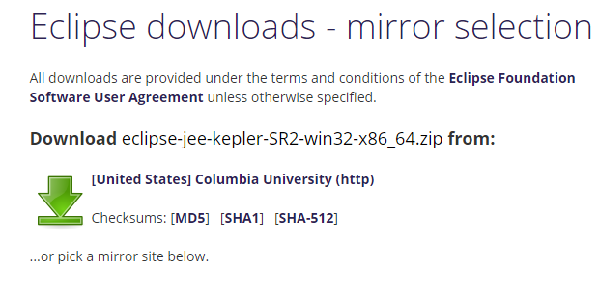

Once you down load unzip it and go to : eclipse-jee-kepler-SR2-win32-x86_64\eclipse

There you will find eclipse icon ,just double click on it to open .you can right on it and chose send to desktop to create a shortcut on your desktop so that from next time you can directly open it from your desktop.

**Open the Eclipse and use the default workspace:**

Open the eclipse and use the default workspace its showing

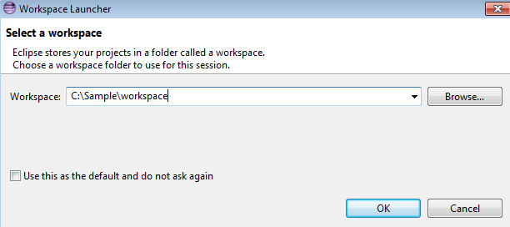

Click ok and it will open the Tool

**Installing SAP UI5 plug in :**

Go to help-->Install new software as below

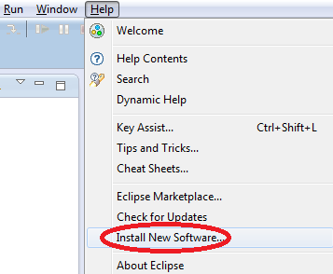

**Click on Add Button and give the details as shown below and click ok**

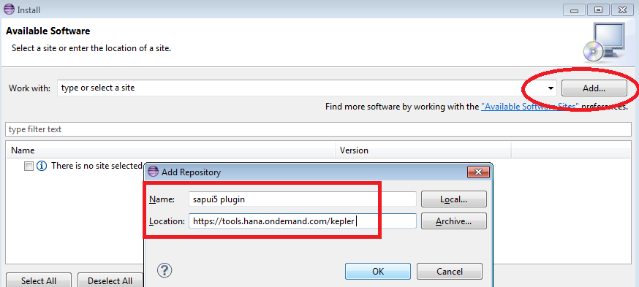

**Select the UI Development Toolkit for HTML5 and click next**

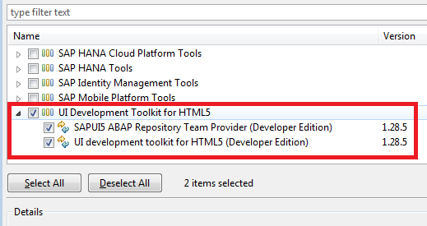

It will take some time to install the plug in once it completes just click next and finish.

**Creating a Simple Application in UI5:**

1. **Create New Application using the below path**

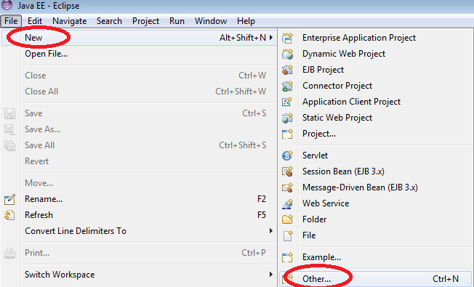

1. **Select Application project and click next**

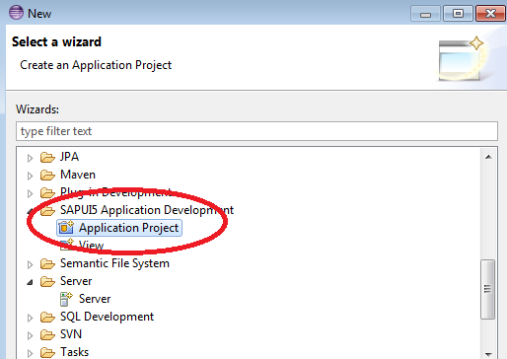

1. **Enter the project name , use the default sap.m liabrary and click Next**

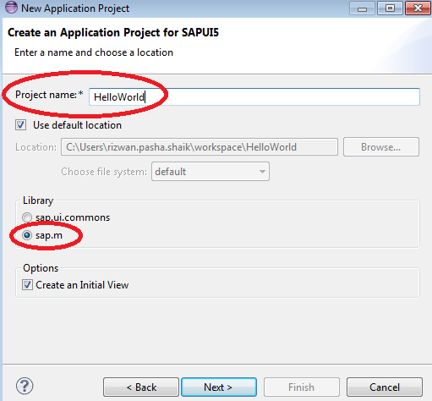

1. **Enter the View Name and select view type as XML , click on Next**

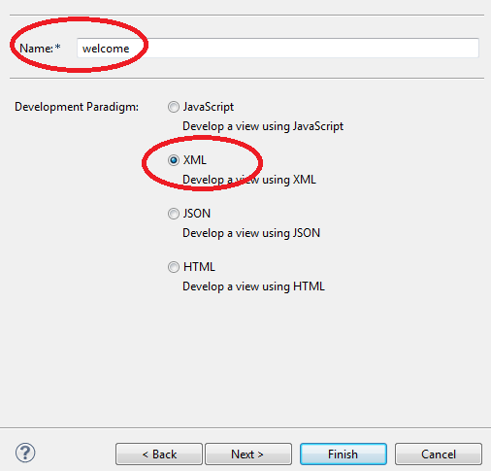

1. **You will get the project Structure like this**

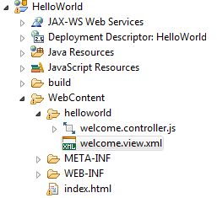

1. **Right click on Index.html and run as webApp preview as below**

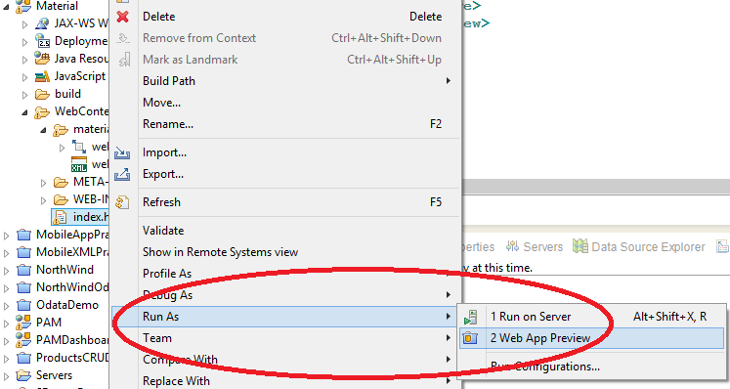

1. **You will get the below output**

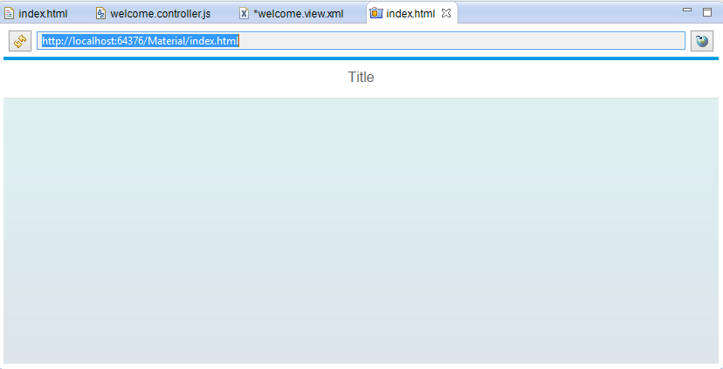

1. **Copy the Url and open a browser and paste. You will get the out put as below**

**p**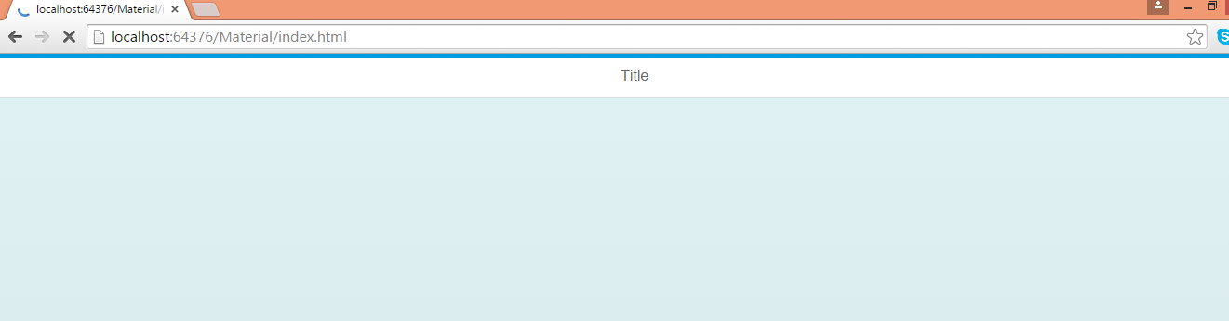

1. **Lets Change the Title of the Page . Go to View and in the <page> tag write as below**

<Page title=*"Welcome to SAP UI5"*>

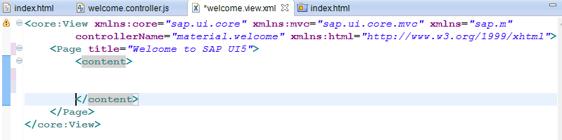

1. **Now Save all and just refresh the page (browser) . (No need to run the page again by going to index-> run as --> webapp preview)**

**you will get the below output.(title changed)**

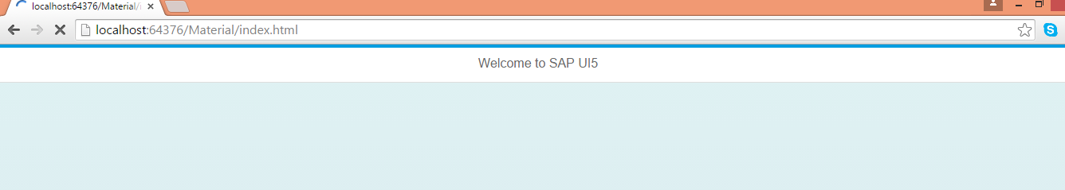

1. **Let us create basic UI Elements now (Label, Input field and Button). Paste the below code (recommended : type the code don't paste so that you will habituated to coding) inside <content> tag**

<Label text=*"Enter your First Name"*></Label>

<Input type=*"Text"* width=*"300px"*></Input>

<Button text=*"Submit"* type=*"Emphasized"* ></Button>

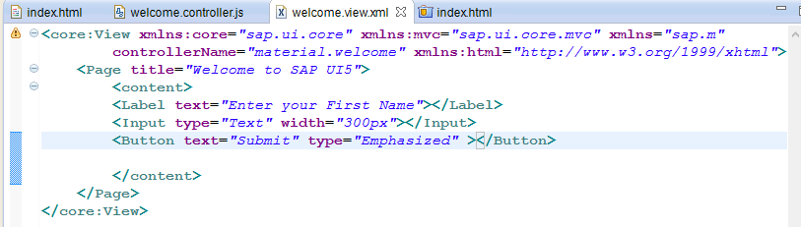

1. **Save All and Refresh the Browser to see the output**

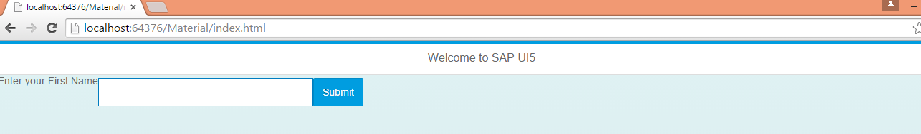

1. **Now lets display a Alert message on click of this Button**

Open the view and add "press=onClick" event to the Button as below

<Button text=*"Submit"* type=*"Emphasized"* press=*"onClick"*></Button>

Now we need to implement this "onClick" function in the Controller . So Open the Controller ,go to the complete Bottom and paste the below code

onClick: **function**()

{

alert("You Clicked meeeeeeeee!");

}

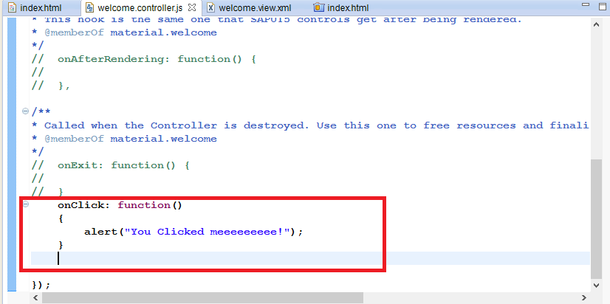

1. **Save all and refresh the browser**

**Click on the Button , you will get the below output**

